Convert the Excel thrombophilia calculator application into an interactive web-based app.
Here is my Excel file and documentation.
The app should allow users to input values, calculate decision thresholds for treatment, and generate associated graphs.
You will see that there are 8 EXCEL tabs. First two (Introduction and Tutorial-examples) are README/description files. The last one (Comments) can be ignored. I also attached two PDF files that you should read first to understand science and rationale for the EXCEL calculator (that deals with 69 recommendations/clinical scenarios).
Fixed/default input values:
• RRt = 1.65
• Tp = 0.38
• RRrx = 0.15 (95% CI 0.1 to 0.23) [Note 1-RRrx=RRRrx, relative risk reduction; 0.85 (95% CI: 0.77 to 0.90),]
• RRbleed = 2.17 [ (95% CI: 1.40–3.35) [Note RRIbleed=relative risk increase_bleed=RRbleed-1]
• Hnorx = 0.005 (low bleeding) or 0.015 (high bleeding) (baseline bleeding risk without treatment)
• Accepts user input (e.g. select recommendation, bleeding risk, RV, RRrx, RR),
- pVTE risk without treatment [default as per data given EXCEL calculator]
-Lookup Table: ASH recommendations tab contains all 69 scenario values (pVTE, ASH recommendation, model recommendation).
- user to change inputs:
RRR: from 0 to 1
RRbleed: 1 to 10
RV= from 0.01 to 10
pVTE risk without treatment

Output
• Computes thresholds (Pt, Ptt, Prx),
• Graphs decisions and outputs (VTE/bleeding rates as bar graphs with numeric numbers above each graph),
• Create the EUT graph only; you can ignore acceptable regret (ARgT) outputs.
Contrast pVTE (pVTE risk without treatment) against thresholds. All three thresholds should be shown in the EUT graphs as vertical lines,
Here is an example how the EUT graph should look like (R1 recommendation, low bleeding risk) . Note that because VTE and bleeding are “bad” outcomes, the lower value on Y axis indicates better strategy

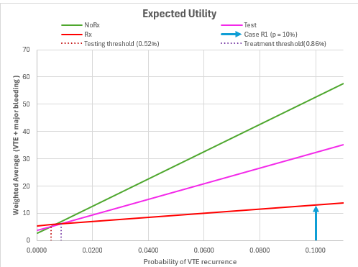
• Displays the (EUT) decision model’s treatment recommendation (Treat, Test, or Do Nothing),
- Display ASH treatment recommendation (Treat, Test, or Do Nothing),
- Display agreement between decision model’s and ASH recommendations

Would it be possible for you to convert this into user-friendly, pleasing web-based, interactive application? Before final version, can we test the accuracy of outputs and functionality of the application in your environment? That is, can you show the user interface with default inputs that the user can change, graphical outputs, the model and ASH recommendations with agreement as per above?

--
Short;
Convert the Excel thrombophilia calculator application into an interactive web-based app.
Here is my Excel file and documentation.
The app should allow users to input values, calculate decision thresholds for treatment, and generate associated graphs.
You will see that there are 8 EXCEL tabs. First two (Introduction and Tutorial-examples) are README/description files. The last one (Comments) can be ignored. I also attached two PDF files that you should read first to understand science and rationale for the EXCEL calculator (that deals with 69 recommendations/clinical scenarios.

Output
• Computes thresholds (Pt, Ptt, Prx),
• Graphs decisions and outputs (VTE/bleeding rates as bar graphs with numeric numbers above each graph),
• Create the EUT graph only; you can ignore acceptable regret (ARgT) outputs.
Contrast pVTE (pVTE risk without treatment) against thresholds. All three thresholds should be shown in the EUT graphs as vertical lines,
Allow user to change the inputs:
RRR: from 0 to 1
RRbleed: 1 to 10
RV= from 0.01 to 10
pVTE risk without treatment

